

**CLOTHING SHOP Project Report**

**Software Requirement Specification**

– Hanoi, September 2021 –

**Table of Contents**

*A. Architecture Design* 3

I. Overview 3

Code Packages/Namespaces 3

II. Code Designs 3

1. <Feature/Function Name1> 3

a. Class Diagram 4

b. Class Specifications 4

XYZ Class 4

ABC Class 4

c. Sequence Diagram(s) 4

d. Database queries 5

2. <Feature/Function Name2> 5

III. Database Design 5

1. Database Schema 5

2. Table Description 6

# *A. Architecture Design*

# I. Overview

## Code Packages/Namespaces

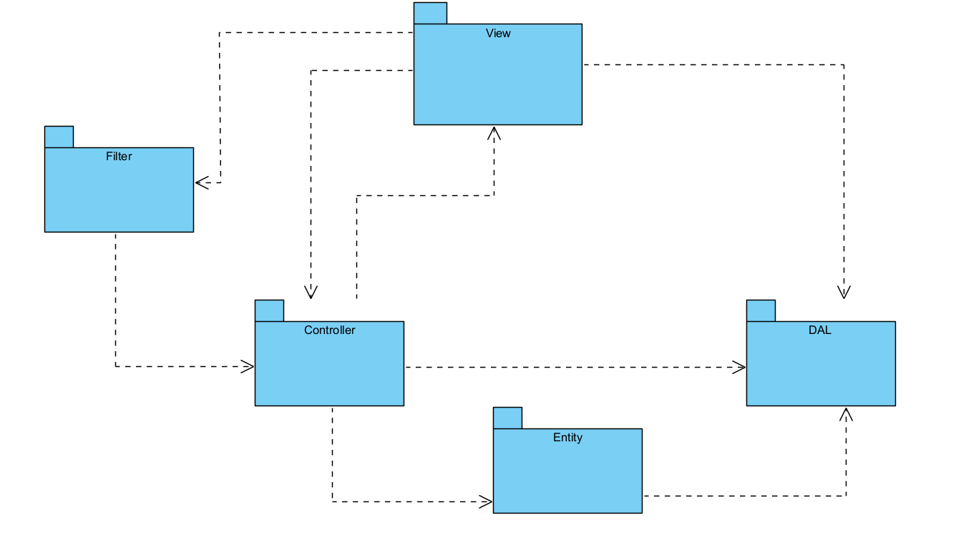

***Package descriptions & package class naming conventions***

|  |  |  |
| --- | --- | --- |
| **No** | **Package** | **Description** |
| *01* | *View(Web Pages)* | *Provide interaction with user ,GUI*  *Java Class Naming Convention* |
| *02* | *Controller* | *Control the data flow between view and model (DAO),Control the logic of the system*  *Java Class Naming Convention* |
| *03* | *DAL* | *Provide the connection to the Database, Extract data for the system* |
| *04* | *Filter* | *Control the redirection between Pages in View and from View to Controller*  *Java Class Naming Convention* |
| *05* | *Entity* | *Define the logic of data extracted from Database*  *Java Class Naming Convention* |
| *06* | *Util* | *Utility Function* |

# II. Code Designs

## 1. <Feature/Function Name1>

*[Provide the detailed design for the function <Feature/Function Name1>. It include Class Diagram, Class Specifications, and Sequence Diagram(s)]*

### a. Class Diagram

*[This part presents the class diagram for the relevant feature]*

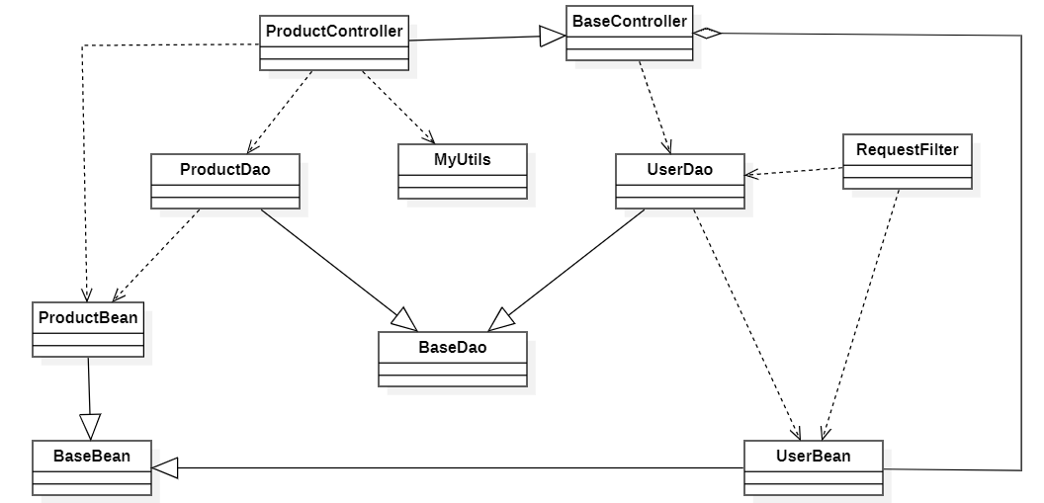

### b. Class Specifications

*[Provide the description for each class and the methods in each class, following the table format as below]*

#### XYZ Class

*[Provide the detailed description for the class methods]*

|  |  |  |
| --- | --- | --- |
| **No** | **Method** | **Description** |
| *01* | *<method name>* | *<Description of the method, including the inputs, outputs & internal method processing>* |
|  |  |  |

#### ABC Class

***Class Methods***

*[Provide the detailed description for the class methods]*

|  |  |  |
| --- | --- | --- |
| **No** | **Method** | **Description** |
| *01* | *<method name>* | *<Description of the method, including the inputs, outputs & internal method processing>* |
|  |  |  |

### c. Sequence Diagram(s)

*[Provide the sequence diagram(s) for the feature, see the sample below]*

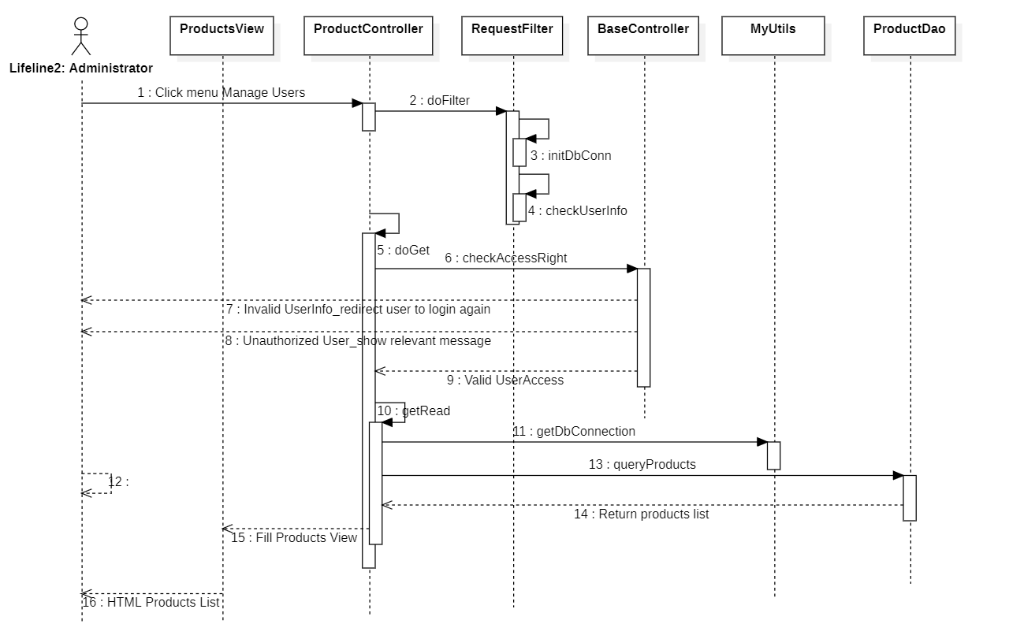

### d. Database queries

*[Provide the detailed SQL (select, insert, update...) which are used in implementing the function/screen]*

## 2. <Feature/Function Name2>

…

# III. Database Design

## 1. Database Schema

*[Provide the tables relationship like example below – following MySQL database naming convention]*

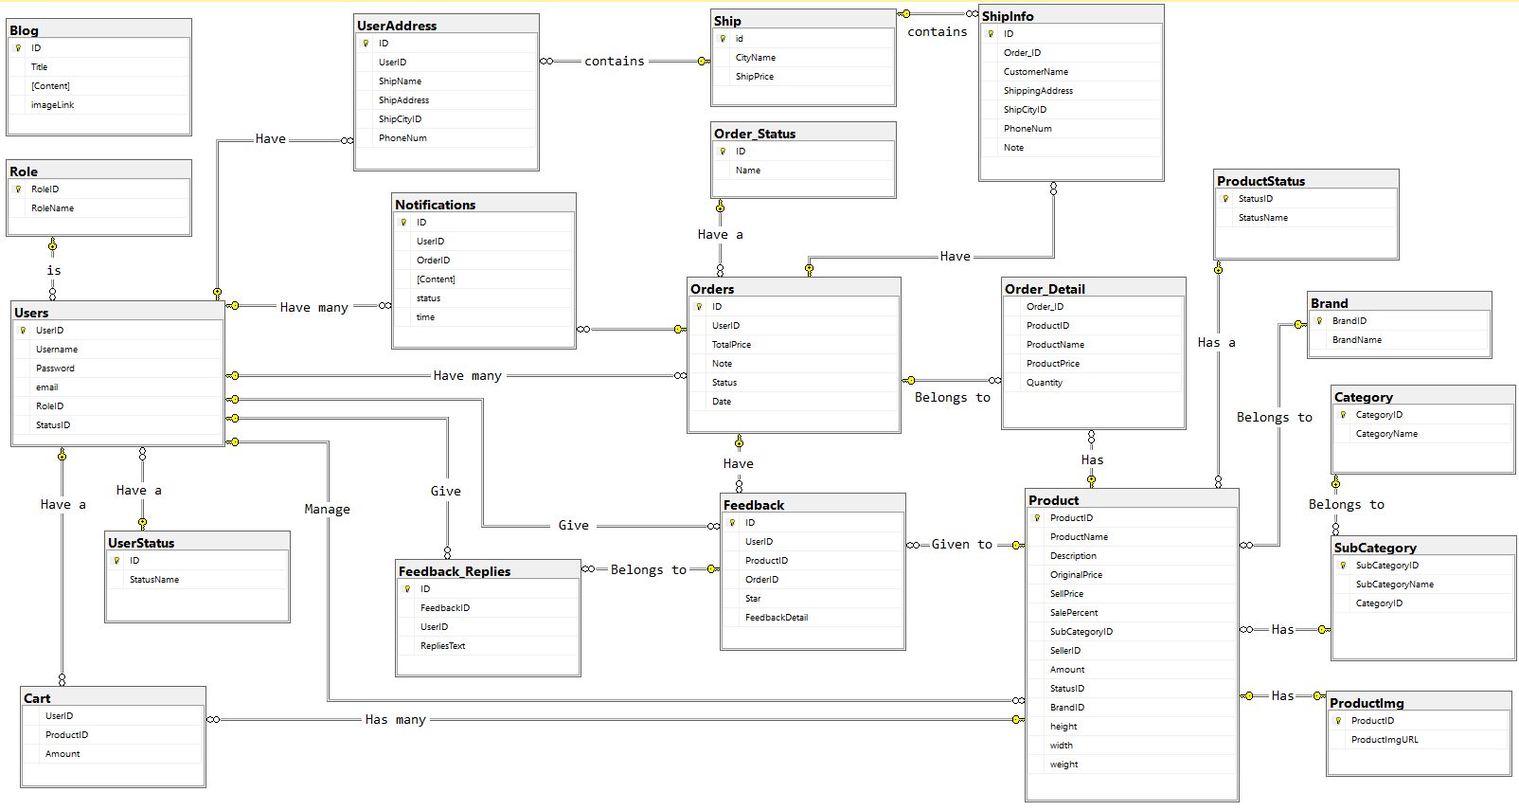

## 2. Table Description

|  |  |  |
| --- | --- | --- |
| **No** | **Table** | **Description** |
| *01* | *Blog* | *Blog content + image*  *- Primary keys: ID*  *- Foreign keys:* |
| *02* | *Role* | *Role of a user ( Admin,Marketing,Sale,Customer )*  *- Primary keys: RoleID*  *- Foreign keys:* |
| *03* | *UserStatus* | *Account activation status*  *- Primary keys: ID*  *- Foreign keys:* |
| *04* | *Ship* | *Shipping price for each city*  *- Primary keys: id*  *- Foreign keys:* |
| *05* | *Order_Detail* | *Detail of each product in order*  *- Primary keys:*  *- Foreign keys: OrderID, ProductID* |
| *06* | *UserAddress* | *Address for each user*  *- Primary keys:ID*  *- Foreign keys: UserID, ShipCityID* |
| *07* | *Users* | *Users*  *- Primary keys: UserID*  *- Foreign keys: RoleID,StatusID* |
| *08* | *Notification* | *Notification data*  *- Primary keys: ID*  *- Foreign keys: OrderID, UserID* |
| *09* | *ShipInfo* | *Shipping info for each order*  *- Primary keys: ID*  *- Foreign keys: Order_ID, ShipCityID* |
| *10* | *Order* | *Order data*  *- Primary keys: ID*  *- Foreign keys: UserID,Status* |
| *11* | *Feedback* | *Feedback of a product order*  *- Primary keys: ID*  *- Foreign keys: UserID,ProductID, OrderID* |
| *12* | *Feedback_Replies* | *Replies of feedbacks*  *- Primary keys: id*  *- Foreign keys: FeedbackID,UserID* |
| *13* | *Order_Status* | *Status of a order*  *- Primary keys: ID*  *- Foreign keys:* |
| *14* | *Product* | *Product Data*  *- Primary keys: ProductID*  *- Foreign keys: SubCategoryID,SellerID,StatusID,BrandID* |
| *15* | *Category* | *Category Data*  *- Primary keys: CategoryID*  *- Foreign keys:* |
| *16* | *SubCategory* | *Sub Category ID*  *- Primary keys: SubCategoryID*  *- Foreign keys: CategoryID* |
| *17* | *Productimg* | *Image of products*  *- Primary keys:*  *- Foreign keys: ProductID* |
| *18* | *ProductStatus* | *Status of a product*  *- Primary keys: StatusID*  *- Foreign keys: StatusName* |
| *19* | *Brand* | *Brand data*  *- Primary keys: BrandID*  *- Foreign keys:* |
| *20* | *Cart* | *Cart info for each user*  *- Primary keys: UserID*  *- Foreign keys: ProductID* |

***B. Database Table Diagrams***



***C. Data Dictionary***

**Group 1: Online Shop**

|  |  |  |  |  |
| --- | --- | --- | --- | --- |
| **#** | **Table** | **Attribute name** | **Type** | **Description** |
| 01 | Blog | ID | Int | Blog ID, auto generated |
| Title | nvarchar | Title of the Blog |
| Content | nvarchar | Content of the Blog |
| imagelink | nvarchar | Link of image used in the Blog |
| 02 | Role | RoleID | int | Role ID, auto generated |
| RoleName | nvarchar | Roles name such as Admin, Seller, Customer, Marketing |
| 03 | Users | UserID | int | User ID, auto generated |
| Username | nvarchar | Username of account for user to login or sign up |
| Password | varchar | Account password |
| email | nvarchar | Email of user |
| RoleID | int | User’s role in system |
| StatusID | int | Status of user |
| 04 | UserStatus | ID | int | Status ID, auto generated |
| StatusName | nvarchar | Status value of user such as active, gmail login |
| 05 | Cart | UserID | int | UserID of user who has the cart |
| ProductID | int | ID of product in the cart |
| Amount | int | The quantity of product in the cart |
| 06 | UserAddress | ID | int | UserAddress ID, auto generated |
| UserID | int | ID of the user for the address |
| ShipName | nvarchar | User’s name |
| ShipAddress | nvarchar | Address of the user in detail |
| ShipCityID | int | ID of City in address |
| PhoneNum | varchar | User’s phone number |
| 07 | Notifications | ID | int | Notification ID, auto generated |
| UserID | int | ID of user who has the notification |
| OrderID | int | ID of the order |
| Content | nvarchar | Notification content |
| status | char | Status of the notification |
| time | datetime | Date and time of the notification |
| 08 | Feedback_Replies | ID | Int | Feedback reply ID, auto generated |
| FeedbackID | int | Customer feedback |
| UserID | int | ID of admin/ moderator of the website |
| RepliesText | nvarchar | Replies of admin/ moderator of the website to the customers feedbacks |
| 09 | Ship | ID | Int | Ship City ID, auto generated |
| CityName | nvarchar | Name of city |
| ShipPrice | int | Price for shipping to the city |
| 10 | Order_Status | ID | int | Order Status ID, auto generated |
| Name | nvarchar | Status value of order |
| 11 | Orders | ID | int | OrderID, auto generated |
| UserID | int | ID of user who orders |
| TotalPrice | float | Total Price of the order |
| Note | nvarchar | Customer or seller note |
| Status | int | Status ID in order status |
| Date | Int | Date and time of the order |
| 12 | Feedback | ID | int | Feedback ID, auto generated |
| UserID | int | ID of Customer |
| ProductID | int | Id of the product |
| OrderID | int | Id of the order |
| Star | int | The rating of every product from the customer after buying  From 1 to 5 |
| Feedback Detail | nvarchar | Customer feedback in detail |
| 13 | ShipInfo | ID | int | Ship information ID |
| OrderID | int | Id of Order |
| CustomerName | nvarchar | Name of the Customer |
| ShippingAddress | nvarchar | Address for Shipping in detail |
| ShipCityID | int | ID of the city in Ship table |
| PhoneNum | varchar | Customer’s phone number |
| Note | nvarchar | Ship information note |
| 14 | Order_Detail | ID | int | Order_Detail ID, auto generated |
| OrderID | int | ID of the order |
| ProductID | int | Id of the product in the order |
| ProductName | nvarchar | Name of the product |
| ProductPrice | int | Price of the product in the order |
| Quantity | int | Quantity of the product in the order |
| 15 | Product | ProductID | int | Product Id, auto generated |
| ProductName | nvarchar | Name of the product |
| Description | nvarchar | Product description by seller |
| OriginalPrice | int | Original Price of the product |
| SellPrice | int | Sell Price of the product |
| SalePercent | Int | Diiference between Original Price and Sell Price in percent |
| SubCategoryID | Int | ID of the Product’s subcategory in SubCategory table |
| SellerID | int | Id of the Seller |
| Amount | int | Available product amount |
| StatusID | int | StatusID of the product in ProductStatus table |
| BrandID | int | ID of the Product’s brand in Brandtable |
| height | float | Product’s height |
| width | float | Product’s width |
| weight | float | Product’s weight |
| 16 | ProductStatus | StatusID | int | Product status id, auto generated |
| StatusName | nvarchar | The status value of the product |
| 17 | Brand | BrandID | int | Id of the brand, auto generated |
| BrandName | nvarchar | The manufacturer name of the product |
| 18 | SubCategory | SubCategoryID | int | Sub category id, auto generated |
| SubCategoryName | nvarchar | The information of SubCategories of products |
| CategoryID | int | Id of the category has the sub category |
| 19 | ProductImg | ProductID | int | Id of the product |
| ProductImgURL | varchar | URL link to the product image |
| 20 | Category | CategoryID | int | Category Id, auto generated |
| CategoryName | nvarchar | Name of the Category |

***D. Screen Flow***

***1) Screen Flow For User***

***2) Screen Flow For Adminstator***

***3) Screen Flow For Seller***

